Session 10

- Write a Python function bayes_posterior(prior, likelihood, evidence) that calculates and returns the posterior probability using Bayes theorem formula for given values.
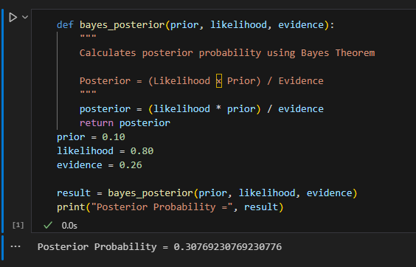
- Given the following scenario: On Swiggy, 10% of restaurants are 'premium', and 80% of premium restaurants offer a discount, while only 20% of regular restaurants do. If you see a discount, use Bayes theorem in code to find the probability that the restaurant is premium.<br><br><em><strong>Hint:</strong> Define prior, likelihood, and evidence in your code with comments.</em>
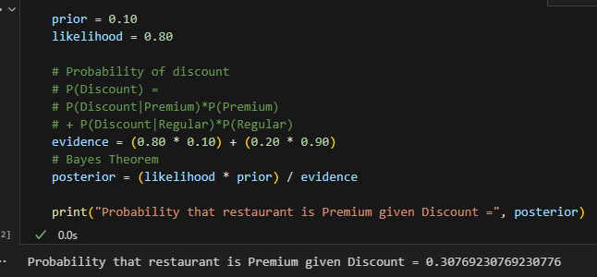

- Simulate a basic spam detection filter: Given a list of 20 email subjects (some spam, some not), and the probability that 'free' appears in spam vs non-spam emails, write code to calculate the probability an email is spam if it contains 'free', using Bayes theorem.
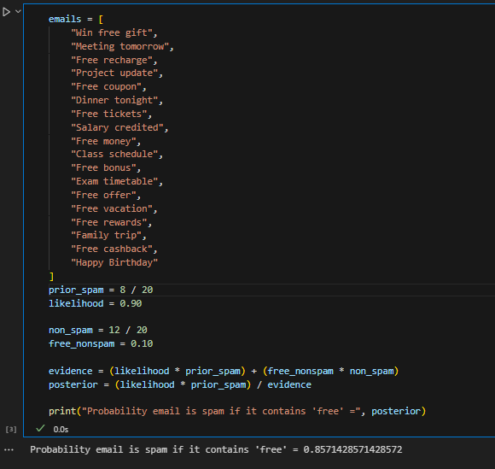
- Use ChatGPT or Copilot to generate a real-world Bayes theorem example related to any app you use (Instagram, Zomato, Flipkart, etc.), then write code to solve it and submit both the prompt you used and your code.
